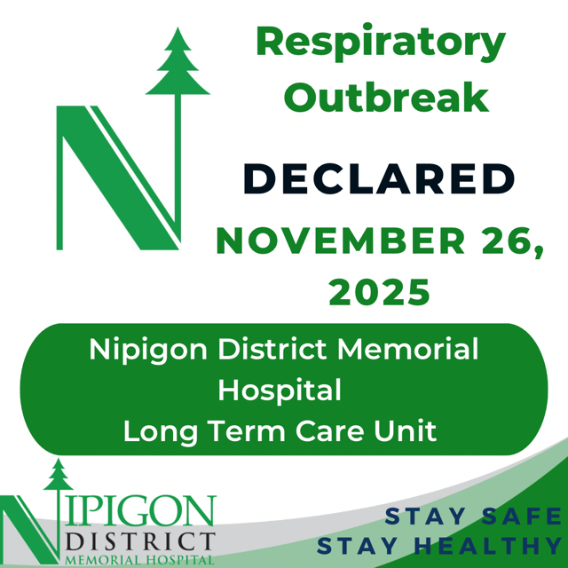

Community Notice

November 26, 2025 - Nipigon District Memorial Hospital is reporting that a respiratory outbreak has been declared by the Thunder Bay District Health Unit (TBDHU) in our Long-Term Care as of today, Wednesday November 26, 2025.

A Respiratory Outbreak is declared in a hospital setting when at least two confirmed positive cases are connected.

The individuals who have tested positive for respiratory illness are currently in self-isolation.

NDMH update - To help contain any further spread, NDMH will be limiting visitors to Essential Care Partners per resident until further notice. An Essential Care Partner is defined as someone who provides physical, psychological and/or emotional support, that is deemed important to the resident's care by the care team in collaboration with the resident.

NDMH will also be implementing outbreak management measures, including increased infection prevention and control practices and surveillance testing for affected individuals. All patients/residents, along with NDMH staff who work in the unit, will be closely monitored for symptoms. NDMH will be working closely with the TBDHU to manage the outbreak and to protect residents, patients and staff. #NDMH ”

