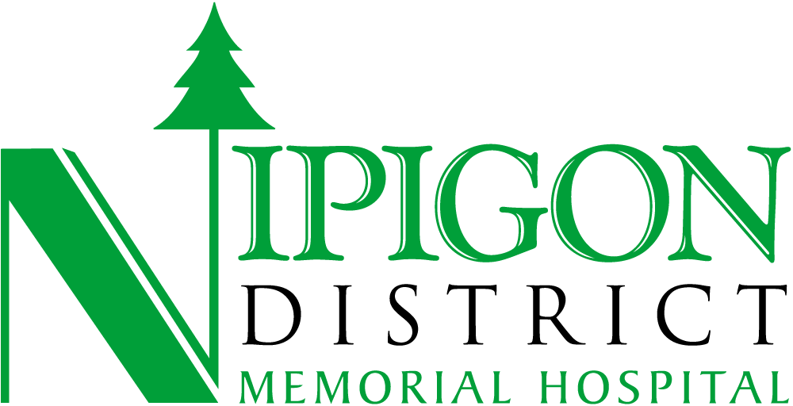

Thank you for your interest in serving as a governance volunteer for the Board of Directors of Nipigon District Memorial Hospital. Please review the section below, complete the application and submit it along with your current resume to:

admin@ndmh.ca

Executive Coordinator
Nipigon District Memorial Hospital, PO Box 37, Nipigon, ON P0T 2J0

Eligibility Criteria and Conditions of Appointment

- Must be at least 18 years of age
- Have not been found under the Substitute Decision Act, 1992 or under the Mental Health Act to be incapable of managing property
- Have not been found to be incapable by any court in Canada or elsewhere
- Does not have a status of bankrupt
- Must have their principle residence, or carry on business within the area of Noojmawing Sookatagaing Ontario Health District area
- Is not an “ineligible individual” as defined in the Income Tax Act (Canada) or any regulation made under it
- Is not a current employee, the spouse of an employee, or Professional Staff member of Nipigon District Memorial Hospital

Role and Expectations Commitment

First Name: ____________________________ Last Name: ____________________________

Home Address: _______________________________________________________________

Phone: ________________________________ Email Address: ________________________

Language Proficiency - English ( ) French ( ) Other ( )

1. Educational Background Please indicate institution attended, degree or credentials
attained and year of completion.

2. Professional and Employment Background Please provide a chronology of all relevant
work experience starting with the most recent. Indicate employer, your title/position, the
dates you held the position and a summary of your responsibilities.

3. Community Involvement Please include the name of the organization served, your
position and the dates you were involved.

4. Memberships in professional organizations (if applicable)

5. Conflict of interest Disclosure Statement Directors must avoid conflicts between their self
interest and the duty to the hospital. In the space below, please identify any relationship with
any organization that may create a conflict of interest, or the appearance of a conflict of
interest, by virtue of being appointed to the Board of Board Committees.

6. Additional information State experience which will support your ability to serve
effectively as a member of the Board of Directors of Nipigon District Memorial Hospital
and Nipigon District Family Health Team.

7. References Please provide the names and contact information for two persons who
could provide a reference for you. Include name, occupation, address and phone
number.

A skills inventory is a compilation of the skills, education and experiences that Board directors bring to the Hospital. Tracking the skills and abilities of our Directors allows the Hospital to identify skills gaps and be seen as opportunities for board learning.

Knowledge, Skills and Experience

Please indicate your current knowledge, skills and experience for each category

Advanced = 3 Immediate = 2 Beginner = 1 None = 0

 | Advanced  3 | Good  2 | Fair  1 | None  0
Financial Literacy
Government
Strategic Planning
Legal Skills
Safe, Quality Care
Occupational Health and Safety
Human Resources and Compensation
Health Care
Long Term Care
Community Relations
Risk Management
Diversity
Advocacy

Signature: ____________________________________

Date: ________________________________________

