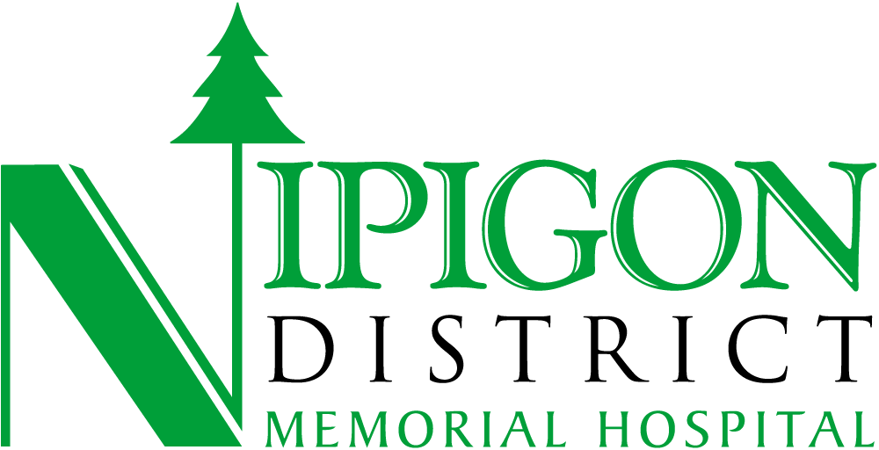
2026-2027 QIP Narrative Report
Prepared by Madison Boudreau, Director of Quality

OVERVIEW
In this section, you may wish to include a description of how your organization is working to improve care or an achievement that your organization is most proud of. This opening paragraph will set the context for what your organization will be working toward through QIP activities.
Recommended length: 250 words

Our organization remains committed to delivering high-quality, person-centred care that adapts to the evolving needs of our community. Over the past year, we have seen increasing complexity in the populations we serve, particularly in the areas of mental health and addictions. In response, this year’s Quality Improvement Plan will continue to focus on the importance of early intervention, appropriate assessments, coordinated care and ensuring timely access to appropriate supports for mental health patients. Furthermore, we recognize that feeling listened to, respected, and safe to speak up without fear of consequences is foundational to high-quality care. Enhancing these aspects of the resident experience is a priority, as they directly influence trust, engagement, and overall outcomes.
We also remain committed to improving the clarity and effectiveness of discharge planning. Ensuring that patients leave hospital with a strong understanding of their next steps is essential for continuity of care, safety, and confidence in the system.
We have introduced two new indicators related to Alternate Level of Care (ALC) patients in response to increasing ALC admission rates. By improving the identification of ALC patients and ensuring appropriate resource allocation, we aim to reduce delays, enhance patient flow, and support better outcomes across the continuum of care. Together, these priorities reflect our ongoing commitment to meaningful, measurable improvement.

ACCESS AND FLOW
Ensuring good access and flow means that the right care is received in the right place at the right time across the health care system. Health service organizations are being asked to focus on initiatives that support access and flow, such as initiatives that support individuals in remaining in the community as long as possible and in avoiding unnecessary hospitalization or emergency department visits, and initiatives that ensure timely access to primary care providers. In this section, describe improvement work that your organization has accomplished or planned to ensure people across Ontario receive the right care in the right place and at the right time. Recommended length: 250 words

Our organization is committed to strengthening access and flow across the care continuum to ensure that individuals receive the right care in the right place at the right time. As patient needs become increasingly complex, particularly for those requiring ongoing supports, we continue to focus on strategies that reduce unnecessary hospital utilization and promote safe, timely transitions. This year, a significant component of our improvement work centers on Alternate Level of Care (ALC), recognizing the growing impact of ALC pressures on patient experience, hospital flow, and system capacity.
To support this work, we have selected two key indicators for our Quality Improvement Plan: the proportion of ALC patients coded correctly and the median time from ALC designation to discharge. Accurate identification of ALC patients is essential for mobilizing the appropriate resources, coordinating with community partners, and ensuring that individuals are connected to the most suitable level of care. By improving coding accuracy, we aim to reduce delays, enhance communication, and support more efficient care planning.
Reducing the time from ALC designation to discharge is equally important. Timely transitions help patients avoid prolonged hospital stays, minimize risk of deconditioning, and improve overall quality of life. Our efforts include strengthening collaboration with community partners, optimizing internal processes, and proactively addressing barriers that contribute to discharge delays. Together, these initiatives reflect our commitment to improving patient flow, supporting community-based care, and contributing to a more responsive and sustainable health system.

EQUITY and INDIGENOUS HEALTH
Ontario Health is committed to driving improved and equitable access, experiences, and outcomes to reduce health inequities and advance Indigenous health across the province. Advancing health equity and Indigenous health for communities in Ontario requires strategic and sustained efforts. In this section, please share work that your organization has accomplished or planned to improve equity and Indigenous health (for example, implementation of an equity, inclusion, diversity, and antiracism workplan or a First Nations, Inuit, Métis, and Urban Indigenous health workplan [which may be based on Service Accountability Agreement obligations]). Recommended length: 250 words

Our organization recognizes that advancing health equity and supporting Indigenous health requires intentional, sustained action, and we acknowledge that we are still early in this journey. While we have taken initial steps to build awareness and identify gaps, we know that more comprehensive and coordinated efforts are needed to ensure equitable access, culturally safe care, and improved outcomes for all individuals we serve. This year, our focus is on strengthening the foundation for long-term equity work by developing clear plans, building internal capacity, and continuing to engage meaningfully with partners.

In the coming year, we intend to strengthen relationships with Indigenous partners and community organizations to better understand local needs and co-design approaches that support culturally appropriate care. While we recognize that meaningful progress will take time, we are committed to building the groundwork necessary to advance equity and improve health outcomes in a respectful, collaborative, and sustainable way.

PATIENT/CLIENT/RESIDENT EXPERIENCE
In this section, share how your organization plans to incorporate information from experience surveys (or other feedback received about care experiences) into quality improvement activities.
Recommended length: 250 words

Our organization is committed to using patient and resident experience feedback as a key driver of quality improvement. Understanding how individuals perceive their care allows us to identify gaps, strengthen communication, and ensure that services remain responsive to the needs of those we support. To measure resident experience in our long-term care home, we will continue to track two core indicators: the percentage of residents who feel they have a voice and are listened to by staff, and the percentage who feel they can speak up without fear of consequences. These indicators are monitored monthly through resident experience surveys conducted at Resident Council, providing ongoing insight into psychological safety, communication, and trust within the home.
We also completed our annual Long-Term Care Resident and Family Satisfaction Survey, which captures feedback on overall experience, communication, care delivery, food and mealtime experience, the home environment, services, and recreational programming. Using this information, we will work collaboratively with residents and families to develop a targeted workplan that addresses identified gaps and supports meaningful improvements.
Beyond long-term care, we remain focused on enhancing the patient experience during hospital discharge. Ensuring that individuals leave with a clear understanding of their next steps is essential for safety, continuity of care, and reducing avoidable readmissions. This work aligns with broader system pressures related to overcapacity, as well-prepared discharges support smoother transitions home and greater success in the community. Together, these efforts reflect our commitment to listening, learning, and integrating patient and resident voices into all aspects of quality improvement.

PROVIDER EXPERIENCE
Many organizations are implementing innovative practices to improve recruitment and retention (e.g., through incentive-based programs for nurses and personal support workers), workplace culture, and staff experiences. In this section, describe practices or initiatives your organization has planned to improve recruitment, retention, workplace culture, or staff experience.
Recommended length: 250 words

Like many health care organizations across the province, we continue to face significant workforce pressures, and while these challenges are widespread, we are focused on doing what we can to support our staff and create an environment where people feel valued and engaged. Over the past year, we completed the Accreditation Canada Global Workforce Survey, which provided direct insight into the employee experience across key domains such as communication, teamwork, leadership, and psychological safety. This feedback has been instrumental in helping us understand strengths, identify areas for improvement, and prioritize actions that matter most to staff. In addition, we conducted an in-house listening tour, during which senior leadership met individually with each department to hear firsthand about workplace culture, operational challenges, and opportunities to enhance staff well-being. These conversations are never over or one-sided; they represent ongoing dialogue that continues to shape our understanding of organizational culture and guide our efforts moving forward.

To further strengthen communication and collaboration, we have integrated “reset meetings” into organizational practice. These meetings provide an opportunity for each department and management to come together collectively, discuss current pressures, and problem-solve as a team. This initiative supports transparency, shared accountability, and a healthier workplace culture.

Our senior leadership team remains deeply attuned to the culture of the organization and is committed to fostering a supportive, respectful, and collaborative work environment. While recruitment and retention remain significant challenges across the health system, we continue to leverage available strategies to attract and retain staff, including flexible hiring approaches, recognition efforts, and ongoing engagement with employees.

SAFETY
Never events are serious patient safety incidents that should not occur if proper preventive measures are in place. In this section, describe your organization’s approach to the prevention of never events as part of its overall patient safety strategy. What steps are in place to prevent never events, particularly in areas such as pressure injury prevention, surgery, or medication safety? Please provide a specific example from one of these areas to illustrate your organization’s approach.
Recommended length: 250 words

Our organization is deeply committed to preventing never events, and medication safety has been a longstanding area of focus within our overall patient safety strategy. Medication-related never events, such as administering the wrong medication or incorrect dosage, are preventable incidents that require strong systems, consistent monitoring, and a culture of safety. Over the years, we have built and refined processes to reduce risk, strengthen communication, and ensure that safeguards are in place at every step of the medication management pathway.

A key component of our approach is the routine tracking and analysis of medication safety incidents through our internal quality performance scorecard. This tool allows us to monitor trends, identify potential system vulnerabilities, and implement targeted improvements. The scorecard functions alongside our Quality Improvement Plan, giving us a broader view of performance and enabling us to respond proactively rather than reactively.

One example of our approach is the use of standardized medication reconciliation processes at transitions of care. Ensuring that medication lists are accurate, complete, and verified at admission, transfer, and discharge helps prevent errors that could lead to serious harm. Staff receive ongoing education on safe medication practices, double-check procedures, and high-alert medication protocols. When incidents or near misses occur, we conduct reviews using our quality risk management system to understand contributing factors and implement corrective actions.

PALLIATIVE CARE
In this section, describe how your organization integrates palliative care into care along the illness trajectory (including end-of-life care) and how the care provided improves the quality of life of patients with life-limiting illnesses (and their families and care partners); consider the Themes and corresponding considerations below.

Please provide 3 specific examples of activities within your organization that demonstrate a commitment to enhancing quality of life. Describe how these activities achieve the standard of care set out in the Quality Standard for Palliative Care or in the Palliative Care Health Services Delivery Framework. If applicable, describe how data and feedback are used to improve care.
Recommended length: 250 words
Our organization is committed to integrating palliative care throughout the illness trajectory to enhance quality of life for patients with life-limiting illnesses and to support their families and care partners. While this year’s Quality Improvement Plan has shifted focus, palliative care remains an internal priority, and we continue to build on the foundational work completed over the past several years. Early identification of palliative patients has been a key QIP indicator in previous cycles, and through that work we have recognized that there is still significant opportunity to strengthen our overall palliative care program.
Early identification continues to guide our approach, as recognizing palliative needs sooner allows the care team to initiate supportive interventions, reduce symptom burden, and ensure timely access to appropriate resources. This aligns directly with the Palliative Care Quality Standard, which emphasizes proactive assessment and coordinated care planning. We also prioritize goals-of-care discussions as a core component of our practice. These conversations ensure that patient values, preferences, and priorities shape decision-making throughout the illness trajectory. By engaging patients and families early and revisiting these discussions as conditions evolve, we support care that is aligned with what matters most to the individual. Finally, we will continue to invest in education for healthcare providers to strengthen communication skills, symptom management, and culturally sensitive palliative care practices. Ongoing learning helps embed palliative principles into everyday care and builds confidence across the team. While we are not yet fully leveraging data, incident reviews, or patient and family feedback in a systematic way, this is the direction we intend to move toward as we continue developing a more coordinated, person-centered palliative care program.

POPULATION HEALTH MANAGEMENT
Population health management, as defined by the Rapid Improvement Support Exchange (RISE) program, is an iterative process that involves gathering data and insights from many partners (including nontraditional health care partners) about an entire population’s health and social needs. These insights inform the co-design of proactive, integrated, person-centered, cost-effective, equitable, and efficient solutions with the goal of improving people’s health needs along the continuum of care and well-being.

In this section, share how your organization is partnering with other organizations (other health care partners or within Ontario Health Teams) and using population health–management concepts to serve the unique health and social needs of people in the community. Focus on the important considerations mentioned in the Resources below when describing your organization’s partnerships and planned work.
Recommended length: 250 words

Recently, our management team conducted a community listening tour as part of our strategic planning process. This engagement included conversations with local health care providers, community agencies, municipal partners, and members of the public. These discussions provided valuable insight into the lived experiences, priorities, and challenges faced by our population, helping us better understand the broader determinants that influence health and well-being. The information gathered through this process is shaping our planning and helping us identify opportunities for more proactive, integrated, and person-centred approaches to care. Themes such as access to mental health supports, transportation barriers, aging in place, and the need for stronger coordination across sectors emerged consistently. These insights reinforce the importance of working closely with community partners to design solutions that reflect local realities.

We continue to collaborate with regional health partners and Ontario Health Team members to explore shared strategies that support smoother transitions, improved access to services, and more equitable care. While we are still early in our population-health management journey, the listening tour has provided a strong foundation for future work. Our goal is to build on these relationships, strengthen data-informed planning, and co-design initiatives that address the health and social needs of our community in a meaningful and sustainable way.

EXECUTIVE COMPENSATION
Under the Excellent Care for All Act, 2010, organizations are required to ensure that the payment of performance--based compensation is tied to the achievement of the quality improvement targets set out in their annual QIP and that this information is made available to the public.

Please describe which positions are defined as executive at your organization and how compensation for each executive is linked to achieving what percentage of the organization’s QIP targets. For each position, please specify if compensation is part of at-risk salary or base salary. Please also state which of the organization’s QIP indicators are included in the executive compensation QIP targets. Please note, this information should match the information given in your organization’s workplan.

We’ve defined (A) the executive-level roles in our organization and the percentage of their salary at risk; (B) the organization’s QIP indicator targets linked to these executives’ performance-based compensation, (C) terms describing how the at-risk salary is paid out in relation to target achievement.

A. Executive-Level Roles and Corresponding Performance-Based Compensation
• President and Chief Executive Officer: 3% of annual base salary
• Chief of Staff: 3% of annual base salary
• Chief Nursing Executive: 3% of annual base salary
• Chief Financial Officer: 3% of annual base salary

B. Quality Improvement Targets
Priority area | Indicator target to be achieved for 100% payout
Patient/Resident Centered | The percentage of patients who responded “yes” to the question: “My discharge plan provided me with a good understanding of the next steps in my care when I left the Hospital” with a target of 80%.
Access & Flow | The percentage of mental health patients who receive an offer for follow up services following an ER mental health visit with a target of 85%

C. Terms
Compensation will be awarded as follows:
3% for Chief Executive Officer, Chief of Staff, Chief Nurse Executive, Chief Financial Officer
- 1.5% tied to the percentage of patients who responded “yes” to the question: “My discharge plan provided me with a good understanding of the next steps in my care when I left the Hospital.”
- 1.5% tied to the percentage of mental health patients who receive an offer for follow up services following an ER mental health visit

Target Achievement 80-100 % = 100 % compensation
Target Achievement 70-80 % = 50% compensation
Target Achievement < 70 % = 0 % compensation

